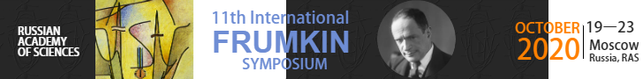

11th International Frumkin Symposium on Electrochemistry

Moscow, Russia, October 19-23, 2020
The Organizing Committee of the Frumkin Symposium invites you for participation in this conference.
Scope of the symposium covers principal areas of modern electrochemistry.

It will be carried out in the form of 8 parallel sections:
Section 1: Fundamental Aspects of Electrochemistry
Section 2: Electrochemistry of Materials
Section 3: Electrochemical Energy Conversion and Storage
Section 4: Bioelectrochemistry and Biomedical Applications of Electrochemistry
Section 5: Electroanalysis
Section 6: Electrochemistry of Ionically Conducting Media
Section 7: Electrochemical Methods in Nuclear Chemistry: Problems and Solutions
Section 8: Electrochemical Corrosion and Protection of Metals

Plenary and keynote lectures will be delivered by prominent electrochemists:
Christian Amatore, Sorbonne University, Paris, France
Plamen Atanassov, University of California, Irvine, USA
Doron Aurbach, Bar-Ilan University, Israel
Juan M. Feliu, University of Alicante, Spain
Peter Pohl, Johannes Kepler University, Linz, Austria
Patrik Schmuki, University of Erlangen, Germany
Jean-Marie Tarascon, College de France, Paris, France
Zhong-Qun Tian, Xiamen University, China
More extensive information is available in file:"Frumkin Symposium_Call for Papers.doc" as well as at the symposium site http://frumkinsymp.ru
Besides the above attracting factors of the symposium, here are other important advantages of this conference for its participants, in particular:
- Large number of slots for oral presentations,
- Presenting authors are entitled to deliver up to two contributions including two oral ones,
- Special "Students' session" will be organized where young poster authors can present their results orally,
- Very moderate conference fee, especially reduced for students,
- Availability of a great number of lodging options inside Moscow offering a large variety of both accommodation facilities and prices, in combination with a perfectly functioning underground transportation system where indications are given in Russian and English,
- Numerous sightseeing objects, etc.
Please register (from March) via http://frumkinsymp.ru to attend the symposium.
For extra information, one may contact Alexander Nekrasov at alexander.nek@gmail.com.
Looking forward to meeting you in Moscow this October.
Mikhail Vorotyntsev
Co-chair of the Organizing Committee
Vice-chair of Division 4 of the ISE

